The Secret to Nvidia’s AI Succes -Nvidia’s magic
The Secret to Nvidia’s AI Success - IEEE Spectrum

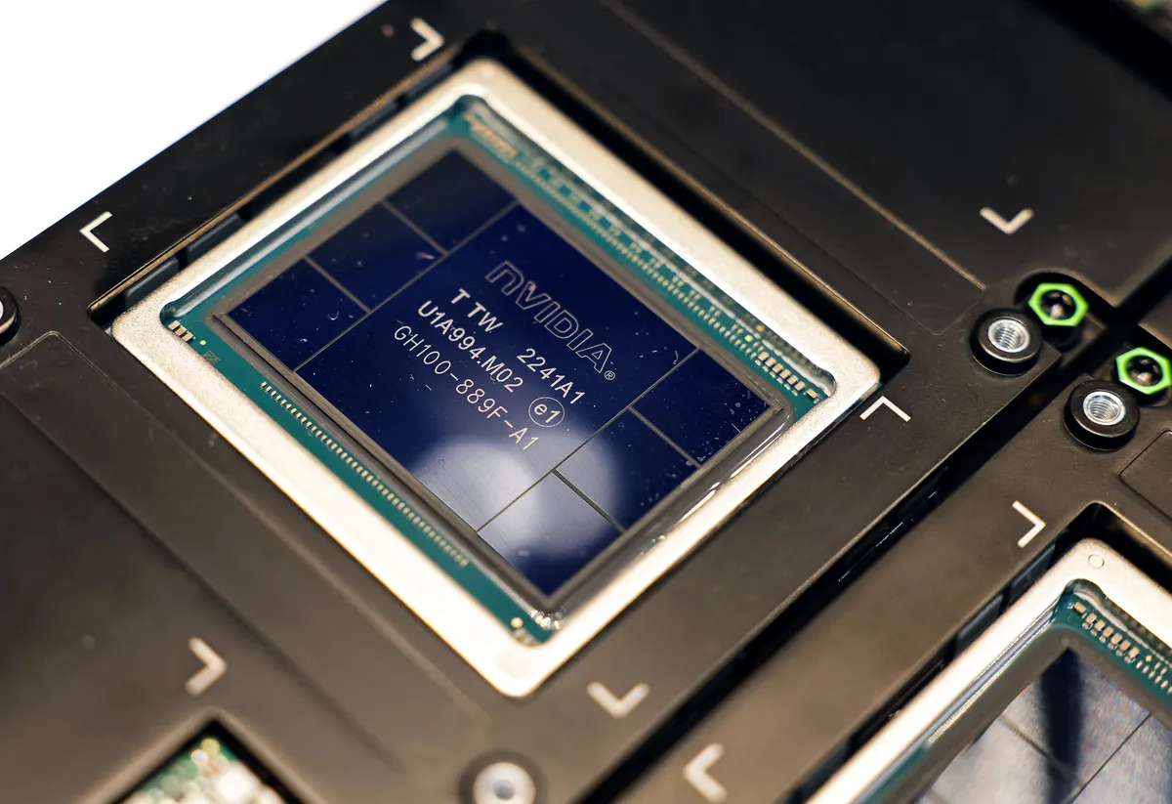

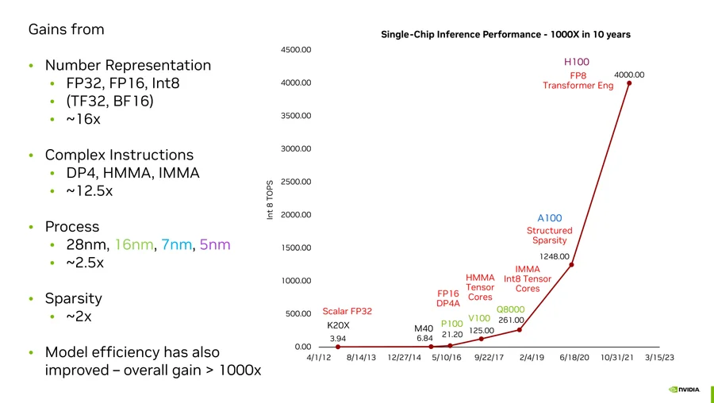

3 reasons:

Number Representation: 16x：
32 bit -> 8 bit, 4x4=16 倍

And it’s clear the floating-point system isn’t ideal. One of the main problems is that floating-point accuracy is pretty consistent no matter how big or small the number. But the parameters for neural networks don’t make use of big numbers, they’re clustered right around zero. So, Nvidia’s R&D focus is finding efficient ways to represent numbers so they are more accurate near zero.

Complex Instructions: 12.5x
“The overhead of fetching and decoding an instruction is many times that of doing a simple arithmetic operation,” said Dally. He pointed out one type of multiplication, which had an overhead that consumed a full 20 times the 1.5 picojoules used to do the math itself. By architecting its GPUs to perform big computations in a single instruction rather than a sequence of them, Nvidia made some huge gains. There’s still overhead, Dally said, but with complex instructions, it’s amortized over more math. For example, the complex instruction integer matrix multiply and accumulate (IMMA) has an overhead that’s just 16 percent of the energy cost of the math.

Moore’s Law: 2.5x

Maintaining the progress of Moore’s Law is the subject of billons and billions of dollars of investment, some very complex engineering, and a bunch of international angst. But it’s only responsible for a fraction of Nvidia’s GPU gains. The company has consistently made use of the most advanced manufacturing technology available; the H100 is made with TSMC’s N5 (5-nanometer) process and the chip foundry only began initial production of its next generation N3 in late 2022.

Sparsity: 2x
After training, there are many neurons in a neural network that may as well not have been there in the first place. For some networks, “you can prune out half or more of the neurons and lose no accuracy,” said Dally. Their weight values are zero, or really close to it; so they just don’t contribute the output, and including them in computations is a waste of time and energy.
Making these networks “sparse“ to reduce the computational load is tricky business. But with the A100, the H100’s predecessor, Nvidia introduced what it calls structured sparsity. It’s hardware that can force two out of every four possible pruning events to happen, leading to a new smaller matrix computation.
“We’re not done with sparsity,” Dally said. “We need to do something with activations and can have greater sparsity in weights as well.”

